MUDSBBJ20262027C

Q1
Q126-27.xlsx
Date - 16/08/2026
Bachdan - MUD160820260235
Matching Mudra_NewCG_Accepted_11993
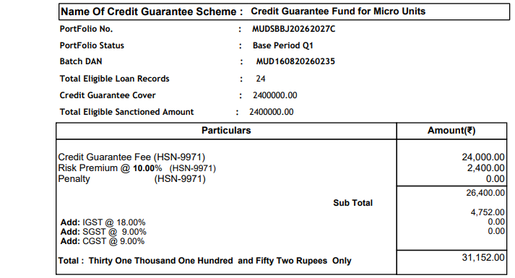

Q2
UpdateCGQ2.xlsx

Update
custid | acctno | outamt | loanclose
2627CR723 | 2627CR723 | 0 | Y
2627CR724 | 2627CR724 | 10000 | IA

Q4
Q426-27.xlsx

Added Exsting cust id
custid | acctno | sancamt | sancdt | frstdisamt | frstdisdt | outamt
InEliCust19 | SameCutInEli22 | 10000 | 01-02-2027 | 9000 | 01-02-2027 | 1000
InEliCust1 | SameCutInEli23 | 605501.57 | 01-02-2027 | 400000 | 01-02-2027 | 10000
InEliCust1 | SameCutInEli24 | 200000.56 | 01-02-2027 | 100000 | 01-02-2027 | 1000
InEliCust1 | SameCutInEli25 | 200000.56 | 01-02-2027 | 9000 | 01-02-2027 | 1000

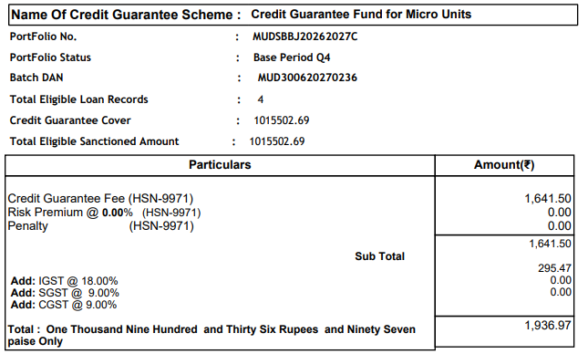

CP1
2627CR721 | 2627CR721 | 10000 | IA
2627CR722 | 2627CR722 | 10000 | IA

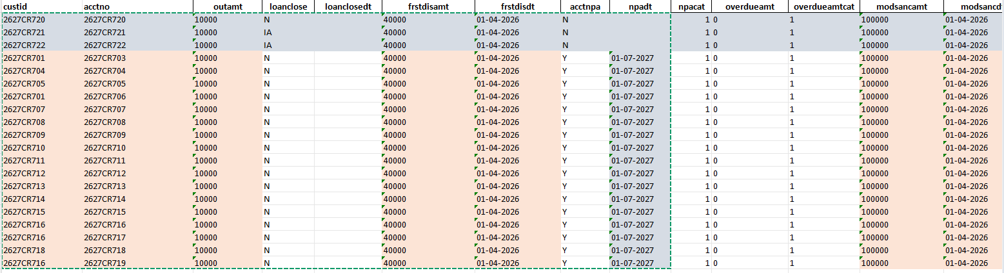

Total uploaded AC - 28

Q1 ---> 1 closed , 1 IA
CP1 -->

CP2
Lodged claim
2627CR701 | 2627CR703
2627CR704 | 2627CR704

